Nuachtlitir Mí na Nollag 2017
Táimid an-ghnóthach sa scoil faoi láthair ag ullmhú don Nollaig. Dhear na páistí cártaí Nollag agus rinne siad an jab orthu. Maith sibh. Táimid ag cleachtadh le haghaidh ár seóanna Nollag agus ag tosú ar ealaín na Nollag.
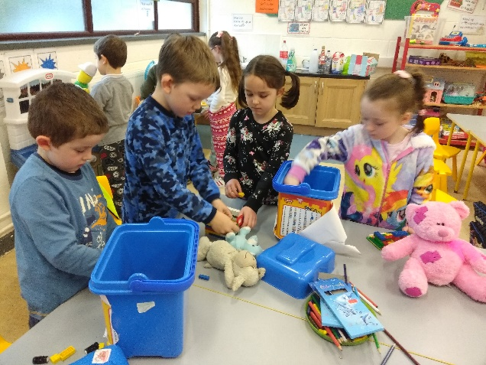
Tá ranganna Gaeilge ar siúl ag na tuismitheoirí gach Déardaoin agus tá ag éirí thar barr leo. Go leor glaochanna gutháin agus nótaí ag teacht as Gaeilge anois. Tá sé ar fheabhas an iarracht a fheiceáil. Críochnaíonn na ranganna ar an Déardaoin an 30ú Samhain.
Tá neart grianghraif den obair a bhíonn ar siúl againn le feiceáil ar shuíomh idirlín na scoile www.gaelscoilmhicaodha.com. Tabhair cuairt air.

Sacar/Futsal
Tá buachaillí Rang a 3 ag glacadh páirte i mbliots sacair taobh istigh ar an 8ú Nollaig. Guímid gach rath orthu. Míle buíochas le Múinteoir Niamh as ucht an traenáil a reachtál.
Lá na bPitseamaí.
Míle buíochas la gach éinne a thacaigh le Clíona agus Tj leis an lá na bpitseamaí. Tiomsaíodh €200 chun cabhrú leo dul go Bucharest.
December Newsletter 2017
We are very busy in school preparing for Christmas at the moment. The children designed Christmas Cards and did an amazing job. €190 was raised for our school. Well done to all. We are practising for our school concert and starting our Christmas art.
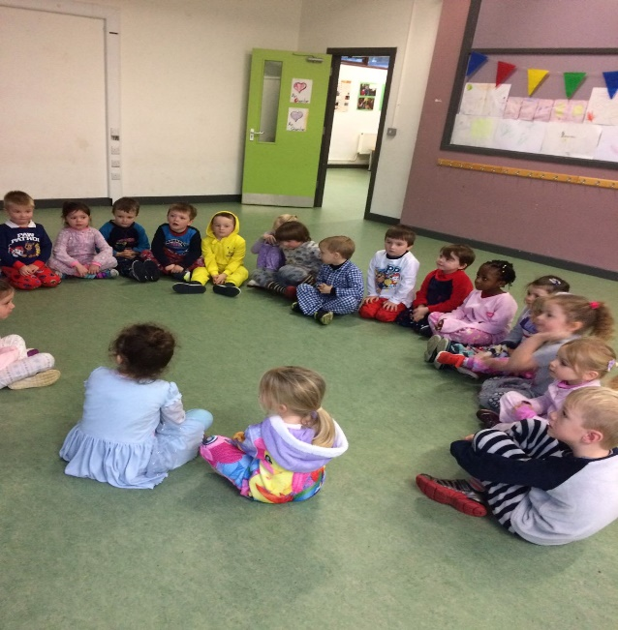
Irish classes for parents are taking place on Thursdays in the school. The parents attending are making great progress. I am getting lots of notes and phone calls in Irish. Well done all. The last class takes place on Thursday November 30th.
There are many photographs of the children at work here in school displayed in our school website www.gaelscoilmhicaodh.aom. Give the site a visit.
Soccer/Futsal
3rd class boys are taking part in an indoor soccer blitz on Friday the 8th of December. Best of luck to them! Huge thanks to Múinteoir Niamh for organising soccer training for the boys.
Pyjama day. We had a really enjoyable Pyjama day in school last week. €200 was raised to help TJ and Clíona go to Bucharest and help children in need.
Pointe Eolais
Níl an Bord Bainistíochta freagrach as páistí a bheith ar suíomh na scoile roimh 8.45am. Beidh múinteoir ar dualgas ó 8.45am ar aghaidh.
Tosaíonn an scoil ag 9.00am. Ba chóir go bhfuil gach páiste sa líne ag 9.00am.
Tá sibh ag déanamh an mhaith leis an lón sláintiúil. Coinnigí suas é – níl cead criospaí, seacláid nó milseáin. Tá cos car chnónna sa scoil.
Má ta páiste as láthair caithfidh tú nóta scríofa a chur isteach. Fiú, ma tá tú tar éis an scoil a chur ar an eolas, tá ort nóta a chur isteach leis an bpáiste nuair a thagann siad ar ais.
Dátaí don dialann
1ú Nollag Aonach na Leabhar 1.30pm-4pm
Luan 4/12/17 – Tá an scoile dúnta. Tá an fhoireann ag freastal ar lá inséirbhise don Churclam Teanga Nua.
20ú Nollaig Ceolchoirm na Nollag.
1.00pm Naíonáin Bheaga agus Naíonaín Mhóra
1.30pm Rang 1
2.00pm Rang 2/3
Ní bheidh Daidí na Nollag ag teacht ar an lá atá na seóanna i mbliana. Dúirt sé go dtiocfaidh sé lá eile atá an scoil níos cúine ionas go bhfaigheann sé go leor ama labhairt leis na páistí.
21ú Nollaig Lá na nGeasaithe Nollag
22ú Nollaig Leath lá – Páistí ag dul abhaile ag 12pm. Scoil go dtí 8ú Eanáir.
29Ú Eanáir Oíche Eolais sa scoil. Scaipigí an focal.

Points of Information.
The Board of Management is not responsible for children on the grounds before 8.45am. A teacher will supervise children from 8.45 am. School begins at 9.00am. Every child needs to be in the line at 9.00am.
You’re doing a great job with the healthy lunches. Keep it up – remember sweets, crisps and chocolate are not permitted. Food containing nuts are not permitted in school.
A written note must be sent in if a child is absent. Even if you call and inform the school, you still need to send a note with the child on their return. If a child misses 20 or more days, the school must inform the Child and Family Agency.
Dates for your diary.
December 1st – Book Fair 1.30pm-4pm
Monday 4/12/17 – School is Closed as the staff attend an in-service day for the New Language Curriculum.
Wednesday 20th of December– School Christmas Concerts
1pm – Junior Infants and Senior Infants
1.30pm First Class
2,00pm 2nd and 3rd class.
Santa said he will not call on the day of our Christmas shows this year. He will come on a quieter day where he will have lots of time to speak with the children.
December 21st – Christmas Jumper day for CMRFCrumlin.
22nd of December. Half day for Christmas holidays. School is closed until Jan 8th.
Jan 29th - Open Night in our new school. Spread the word. We have a limited number of places still available.

Coiste na dtuismitheoirí
Tá grúpa tuismitheoirí ag iarraidh léim paraciúit a dhéanamh ar son na scoile. Má tá suim agat léim a dhéanamh agus airgead a bhailliú don scoil cuir glaoch ar Tara (Mamaí Anthony agus Eloise) ar 0858893734
Aonach na leabhar 1ú Nollag 1.30-4pm. Scaipigí an focal.
Le bhur dtoil cuirigí isteach nithe bacála don díolacán ar an Aoine sin. COSC AR CHNÓNNA!
Faigheann an scoil ceadatán de na leabhair a díoltar le haghaidh na leabharlanna ranga. Tacaigí linn.
Ceannaíodh go leor leabhar nua Gaeilge don leabharlann as airgead atá tiomsaithe ag Coiste na dTuismitheoirí. Míle buíochas le clanna na scoile as a dtacaíocht i gconaí.
Ár scoil nua
Beidh ár scoil nua réidh i Mí Eanáir!!! Ní féidir linn fanacht! Beidh sé réidh i dtreo deireadh na míosa. Táim chun dul ar turas ann ar an Aoine. Glacfaidh mé go leor grianghraif agus cuirfidh mé ar leathanach Facebook na scoile agus ar an suíomh.
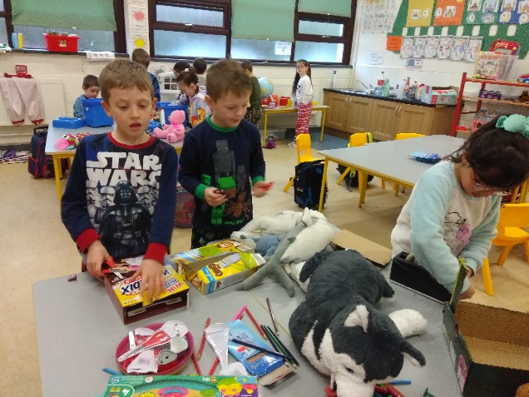
Parent Association
A group of parents are organising a sponsored parachute jump to raise funds for our school. If you would like to participate in a sponsored parachute jump contact Tara (Eloise and Anthony’s mother) on 0858893734
BOOK FAIR December 1st 1.30-4pm Please spread the word. There will be English and Irish books on sale. Books for all ages.
Please send in baked goods for the bake sale on Friday. NO NUTS!!!
The school gets a percentage of the books sold towards books for our school library. Please support.
We purchased lots of new Irish books for our school library with funds raised by the committee. Huge thanks to all families in our school.
Our new School
Our new building will be ready in January!!! We cannot wait to move!! The building will be ready towards the end of January. I am going to visit the site on Friday and I will take lots of photographs. I will upload the photographs to our school facebook page and our school website.

