18ú Samhain 2019
Dátaí don dialann
25/26/27ú Samhain – cruinnithe tuismitheoirí. Cinntigh go bhfuil am socruithe agat. Muna bhfuil glaoch ar Mhuireann san oifig.
Aoine 29ú Samhain – Aonach na Leabhar 9.30-3.30pm
3/12/19 – Lá na nGeasaithe Nollag agus cuairteoir speisialta – Féach nóta a sheol choiste na dtuismitheoirí amach.
18/12/19 Céadaoin – Ceolchoirmeacha na Nollag
Naíonáin Bheaga ag 12.30pm
Naíonáin Mhóra agus Rang 2 ag 1.00pm
Rang 1 agus Rang 5/6 ag 1.30pm
Rang 3 ag 2.pm
20/12/19 – Aoine – Leath-lá ag an scoil ag 12pm.
Ceol-Feadóg Stáin
Tá Múinteoir Aisling ag cur ceachtanna féadóg stáin ar fáil gach Déardaoin ó 2:40-3:30 do Rang 2-5 tar éis an bhriseadh. Le bhur dtoil seolaigí isteach feadóg san eochar ‘D’ leo.
Cór
Tá Cór gach Máirt do Ranganna 2-5 ó 2:40-3:30 .

November 18th 2019
Dates for your diary.
25th/26th/27th of November – Parent Teacher Meetings. Please contact Muireann in the office if you have not arranged a time with the class teacher.
Friday November 29th – School Book Fair – See Parents’ Association update sent home with children on Monday 18th of November
Tuesday 3/12/19 – Christmas Jumper Day and Special Visitor
18/12/19 – Wednesday – School Christmas Concerts
Naíonáin Bheaga at 12.30pm
Naíonáin Mhóra agus Rang 2 at 1.00pm
Rang 1 agus Rang 5/6 at 1.30pm
Rang 3 ag 2.pm
20/12/19 – Friday – Half day. School Closes at 12 pm.
Music- Tin Whistle
Tin whistle lessons continue with Múinteoir Aisling every Thursday until Christmas for 2nd to 5th class from 2:40-3:30. Please ensure children have a tin whistle in the key of D.
Choir
Choir practice le Múinteoir Aoife for 2nd class to 5th class every Tuesday from 2:40-3:30 until Christmas.
Ficheall
Tá Múinteoir Stephanie ag tosnú ficheall gach Déardaoin do Ranganna 2 agus 3ó 2:40-3:30 ag tosú tar éis an briseadh.
Spóirt
Leanfaidh iománaíocht le hEamonn do Ranganna Nai Mhóra - 5 go dtí an Nollaig
Lá Oscailte
Míle buíochas leis na tuismitheoirí a chabhraigh ag an Maidin Oscailte. Bhí slua maith timpeall na scoile.

Sean bréagáin
Is scoil glas muid agus bímíd i gconaí ag iarraidh rúdaí a athúsáid. Má tá éinne ag déanamh glantachán ar bhréagáin atá páistí críochnaithe leo ba bhreá linn d’Aistear leis na Naíonáin.
Bábóga, Lego, ainmhithe, nithe don chistin – aon rud le cruth maith air bheadh fíor fáilte roimhe sa scoil agus bheimid fíor bhuíoch de.

Chess
Chess for 2nd and 3rd classes with Múinteoir Stephanie after school on Thursdays 2:40-3:30pm.
Sport
Hurling with Eamonn will continue on Thursdays for classes Naí Mhóra – Rang 5
Open Morning
Huge thanks to the parents that helped out with our Open Morning last week. We had a very good turnout.

Old Toys
We are a Green School and always trying to reduce, reuse and recycle.
If you are doing a clear out of toys before Christmas please send in any toys that your children may be finished with.
We are looking for dolls, lego, animals and kitchen or shopping toys. We would love any toys that are in good condition for our Aistear in the infant classrooms.

Míle Buíochas,
Norma Ní Chonchúir

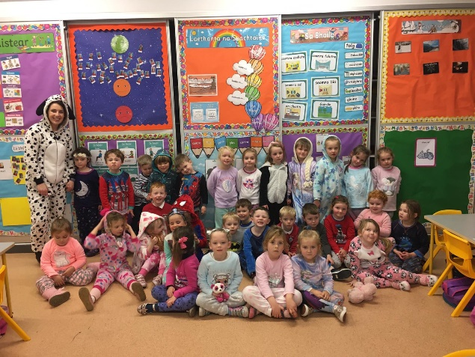

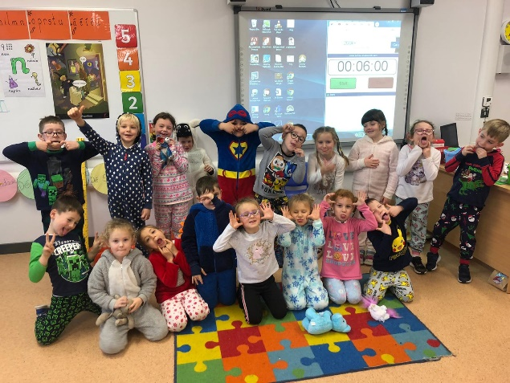

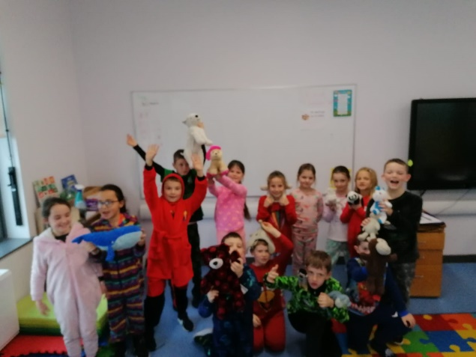
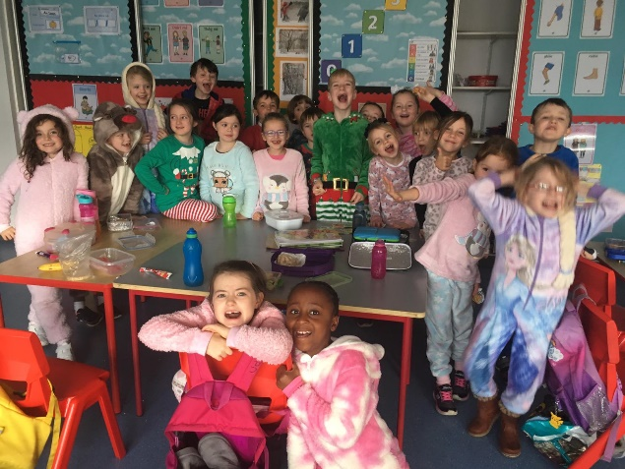

Bhí lá iontach ag lá na Pitseamaí. Míle buíochas libh go léir agus thiomsaíodh €300 d’Alex don Turas go Bucharest.
We had great fun during our Annual PJ Day. Over €300 was raised for Alex for his trip to Bucharest. Huge thanks to you all.

